Building Your First ETL Pipeline Using Azure Databricks Setup Instructions

Step 1: Download Files

- Yellow Taxi Trip Data file:

  - Download file from: https://s3.amazonaws.com/nyc-tlc/trip+data/yellow_tripdata_2018-12.csv Download size: 688 MB

  - Rename the file to YellowTaxiTripData_201812.csv

- FHV Trip Data file:

  - Download file from: https://s3.amazonaws.com/nyc-tlc/trip+data/fhv_tripdata_2018-12.csv Download size: 1.6 GB

  - Rename the file to FHVTaxiTripData_201812_01.csv

- Green Taxi Trip Data file and other files:

  - Available in Demo Files folder

Step 2: Setup Azure Storage service accounts

Azure Storage

- Create Azure Storage account. You would need a globally unique account name.

- Once created, go to Containers service.
- Create a new container → taxisource (example).

- Open taxisource container.

- Click Upload and one by one upload following files:

  - FhvBases.json

  - FHVTaxiTripData_201812_01.csv
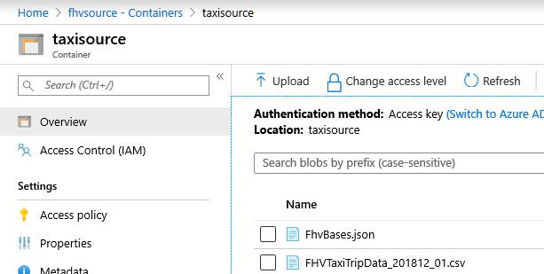
Azure Data Lake Storage Gen1

- Create Azure Data Lake Storage Gen1. You would need a globally unique account name.

- Once created, go to account and open Data Explorer.

- At the root, click Upload and one by one upload following files:

  - YellowTaxiTripData_201812.csv

  - GreenTaxiTripData_201812.csv

  - PaymentTypes.json

  - RateCodes.csv

  - RateCodes.json

  - TaxiZones.csv
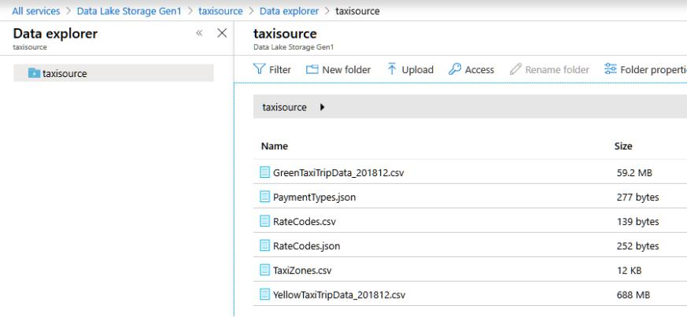

Step 3: Import Databricks notebooks

- After you are done creating Databricks workspace, login to Azure Databricks workspace

using your Active Directory credentials (as shown in module – Setting Up Your Databricks Environment → Setting Up Workspace)

- In the Workspace tab, right click on empty space, and select Import.
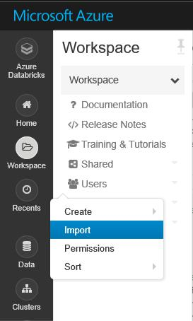
3. Drag and drop the file shared .dbc file and click Import.

- Once imported, you can then see two code folders added to the workspace. These folders contain all the notebooks.

- Though all the notebooks shows up results as well, if you want you can clean up the results for your practice, by going to each notebook (while working) and clearing the results
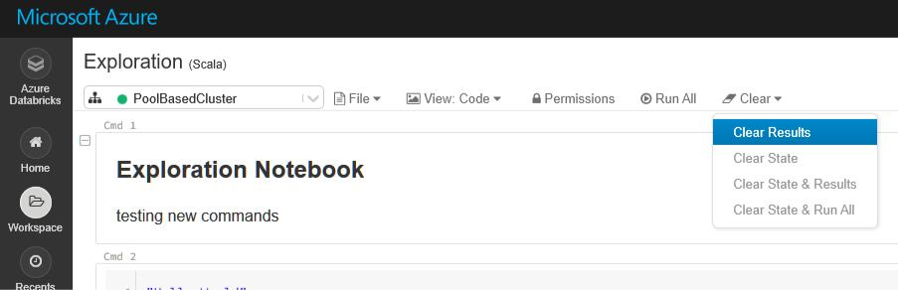

6. Happy Learning!

